Day 1 – 7th February 2005
Sensor comparison: arm bending

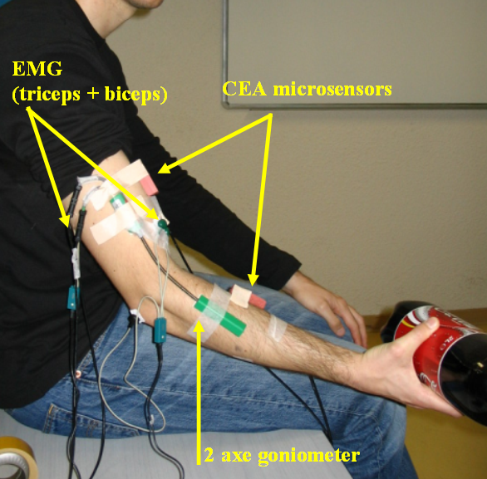
2 EMG:
1- biceps
2- triceps

1 goniometer (2angles):
1- elbow flex/ext
2- elbow add/abd

2 CEA microsensors

The subject was asked to extend his arm and at the signal he had to 1st bend his arm, and 2nd come back to an extended position. The subject was handling a 2kg object.

Acquisition frequency: 500Hz

Subject 1 – Gérard
30 trials. From data01 to data30
NB. There might be a problem at the end of trial data21

Subject 2 – Sébastien
30 trials. From data31 to data60
NB. There might be a problem in data31

Subject 3 – Christine
30 trials. From data61 to data90

Subject 4 – Venkatesh
30 trials. From data91 to data120

Day 2 – 8th February 2005
Gait initiation + sit/stand

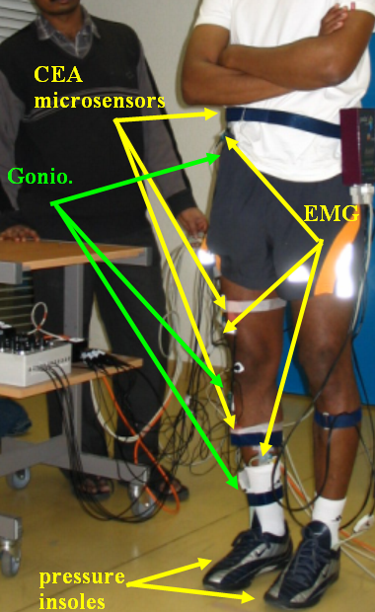
6 EMG:
1- TA (right leg)
2- SOL (right leg)
3- RF (right leg)
4- Gluteus med. (right leg)
5- Abdo.
6- Dors. Supl.

3 goniometers (1 is two angles):
1- ankle dorsiflex/plantar flex
2- knee flex/ext
3- hip flex/ext
4- hip add/abd

3 CEA microsensors:
- config 1: thigh, shank, lower part of the back
- config 2: thigh, shank,upper part of the back

2 pressure insoles

Two synchronized acquisition systems were used:
- insoles: acqu. frequ. 50Hz
- other sensors : acqu. Frequ.: 500Hz

Subject1- Samer

- Experiment 1 - walk
From a standing posture, the subject was asked, at the signal, to walk few meters and stop. Starting with right leg, walking at his natural speed.
10 trials in config 1. From data01 to data10.
NB: - gains for ankle might be different from other goniometers
- no ankle gonio. in data01

- Experiment 2 – grasp1
From a standing posture, the subject was asked, at the signal, to make a step forward with his right leg and grasp an object with his right hand and then come back to initial position.
3 trials in config 1. From data11 to data13

- Experiment 3 – grasp2
From a standing posture, the subject was asked, at the signal, to make a step forward with his left leg and grasp an object with his left hand and then come back to initial position.
3 trials in config 1. From data14 to data16

Subject2- Mickael (droitier)

- Experiment 1 - walk
From a standing posture, the subject was asked, at the signal, to walk few meters and stop.
10 trials in config 1. From data17 to data26.
NB: - gains for ankle might be different from other goniometers
- no ankle gonio. in data17
- early end of insoles acquisition in data21
- insole data missing in data24

- Experiment 2 – grasp1
From a standing posture, the subject was asked, at the signal, to make a step forward with his right leg and grasp an object with his right hand and then come back to initial position.
3 trials in config 1. From data27 to data29 (equilibrium problem at the end of data28)

- Experiment 3 – grasp2
From a standing posture, the subject was asked, at the signal, to make a step forward with his left leg and grasp an object with his left hand and then come back to initial position.
3 trials in config 1. From data30 to data32

- Experiment 4 - walk
From a standing posture, the subject was asked, at the signal, to walk few meters and stop.
2 trials in config 2. From data33 to data34

Subject3- Jean-Denis (Gaucher)

- Experiment 1 - walk
From a standing posture, the subject was asked, at the signal, to walk few meters and stop.
10 trials in config 1. From data35 to data44.

- Experiment 2 – walk
From a standing posture, the subject was asked, at the signal, to walk few meters and stop.
3 trials in config 2. From data45 to data47.

- Experiment 3 – sit to stand
The subject sitting on a chair and at the signal to stand up and hold position.
3 trials in config 2. From data48 to data50

- Experiment 4 – stand to sit
The subject was asked to stand up and at the signal to sit down.
3 trials in config 2. From data51 to data53

- Experiment 5 – stand to sit
The subject was asked to stand up and at the signal to sit down.
1 trial in config 1. data54

Subject4- Rodolphe

The subject was equipped with only the 3 CEA microsensors (on his clothes).

- Experiment 1 – sit to stand
The subject was asked to sit on a chair and at the signal to stand up and hold position.
5 trials in config 1. From data55 to data59

- Experiment2 – stand to sit
The subject was asked to stand up and at the signal to sit down.
5 trials in config 1. From data60 to data64

- Experiment 3 – sit to stand
The subject was asked to sit on a chair and at the signal to stand up and hold position.
5 trials in config 2. From data65 to data69

- Experiment4 – stand to sit
The subject was asked to stand up and at the signal to sit down.
5 trials in config 2. From data70 to data74

Day 3 –9 February 2005
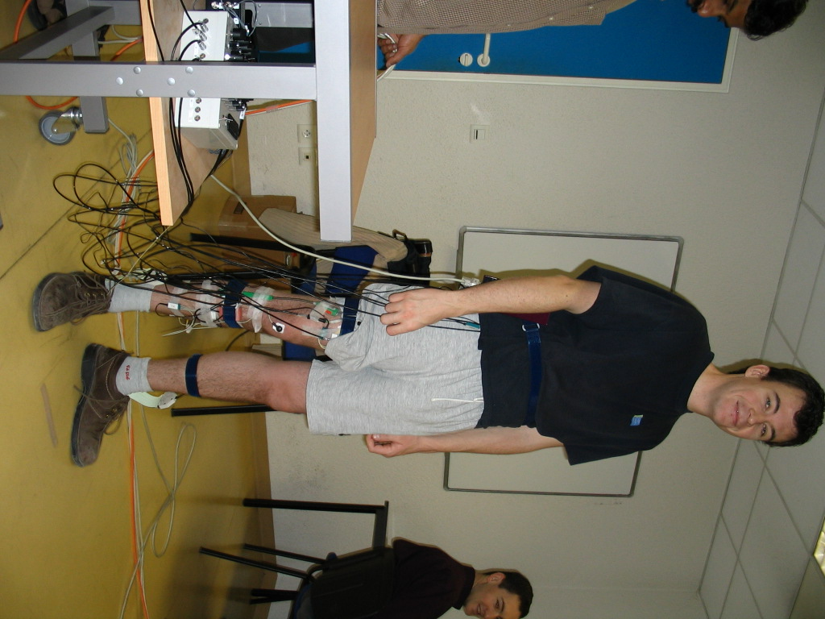
Gait initiation + sit/stand

6 EMG:
1- TA (right leg)
2- SOL (right leg)
3- RF (right leg)
4- Gluteus med. (right leg)
5- Abdo.
6- Dors. Supl.

3 goniometers (1 is two angles):
1- ankle dorsiflex/plantar flex
2- knee flex/ext
3- hip flex/ext
4- hip add/abd

3 CEA microsensors:
- config 1: thigh, shank, lower part of the back
- config 2: thigh, shank,upper part of the back

2 pressure insoles

Two synchronized acquisition systems were used:
- insoles: acqu. frequ. 50Hz
- other sensors : acqu. Frequ.: 500Hz

Subject 1- Vincent

- Experiment 1 - walk
The subject was asked to stand and at the signal he had to walk few meters and stop.
11 trials in config 1. From data01 to data11.
NB: no ankle gonio. in data01

- Experiment 2 – grasp1
The subject was asked to stand and at the signal make a step forward with his right leg and grasp an object with his right hand and then come back to initial position.
3 trials in config 1. From data12 to data14

- Experiment 3 – grasp2
The subject was asked to stand and at the signal make a step forward with his left leg and grasp an object with his left hand and then come back to initial position.
3 trials in config 1. From data15 to data17

Subject 2- Fabien

- Experiment 1 - walk
The subject was asked to stand and at the signal he had to walk few meters and stop.
11 trials in config 1. From data18 to data29.
NB: - inversion of CEA 2 & CEA 3 sensors on trials 18 and 19
- no goniometers : batteries low from trial 18 to 29

- Experiment 2 – stand to sit
The subject was asked to stand up and at the signal to sit down.
5 trials in config 1. From data30 to data34

- Experiment 3– sit to stand
The subject was asked to sit on a chair and at the signal to stand up and hold position.
3 trials in config 2. From data35 to data37

